

RTW PRESS RELEASE
FOR IMMEDIATE RELEASE

RTW Announces New Official Service Centers for US Customers at NAB 2019
With wide user bases on the US East and West coasts, RTW now appoints official service centers in New York and Los Angeles.

(Cologne, Germany, 26 March 2019) RTW focuses on visualizing audio in order to let audio engineers take informed decisions in professional broadcast, production, post production and quality control. Many broadcast and production facilities in the US already use RTW tools, and to make sure that these customers have access to fast, high-quality service, the company has appointed dBm Pro Audio Services in New York and Advanced Musical Electronics Inc. in Los Angeles as authorized RTW service centers.
Both service centers accept items on a walk in, as well as a shipped in basis in order to make sure the entire US is covered and they may be contacted with regard to RTW-service from start April 2019.

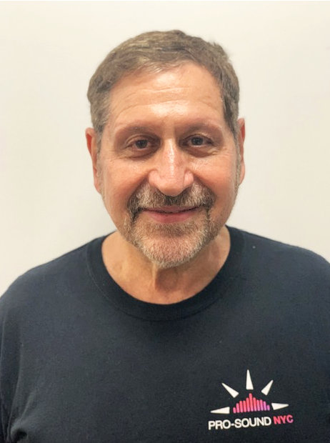
“We are very excited about this extended partnership,” says Steve Dwork, Director Emeritus, dBm Pro Audio Services.
”RTW has provided audio metering solutions for a wide variety of broadcasters and production facilities here on Manhattan, and we’re looking forward to now provide RTW the best service possible for their customers.”

Similarly, the pro audio industry in Los Angeles is now able to receive authorized service in its own neighborhood. Ruth Fischler, CEO at Advanced Musical Electronics Inc. comments:

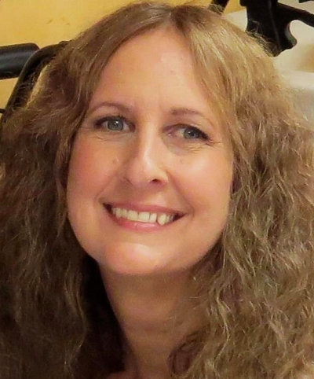
“Our 37 years of experience in providing technical service for audio professionals combined with our Los Angeles location, we consider this a perfect partnership, as we know RTW already has many longstanding customers within the comprehensive music, film, post and broadcast facilities here in California.”
Andreas Tweitmann, CEO of RTW, concludes:


“These service partnership agreements in the US ensures that our many US-based customers will benefit from easier and faster access to highly qualified technicians that will be constantly updated on how to best service our products. At the end of the day, we focus on offering tools that help audio professionals deliver the best results possible by giving them the opportunity to always keep an eye on their audio.

I am confident that Advanced Musical Electronics Inc. and dBm Pro Audio Services will be the perfect partners in pursuing this mission by providing top-notch service to all of our existing and future customers in the US.”

/ENDS
Contact Info, RTW Authorized US Service Centers
dBm Pro Audio Services
320 west 37th st. NY, New York 10018
East Storefront
212-629-0326
About dBm Pro Audio:
dbmproaudio.com
Advanced Musical Electronics Inc.
8665 Venice Blvd.
West Los Angeles, CA 90034
310-559-3157
mail@advancedmusical.com
About Advanced Musical Electronics:
advancedmusical.com
Download hi-res photo of Andreas Tweitmann
Please note! Plain text version available below.

About RTW
RTW, based in Cologne (Germany), has more than 50 years of experience designing, producing and marketing advanced recording-studio equipment, leading and innovating the marketforhigh quality audio metering and monitoring tools. RTW operates a worldwide distribution and service network. For more information on RTW, visit www.rtw.com, www.facebook.com/rtwaudio or call +49 221 709130.

[PLAIN TEXT VERSION]
RTW Announces New Official Service Centers for US Customers at NAB 2019
With wide user bases on the US East and West coasts, RTW now appoints official service centers in New York and Los Angeles.
(Cologne, Germany, 26 March 2019) RTW focuses on visualizing audio in order to let audio engineers take informed decisions in professional broadcast, production, post production and quality control. Many broadcast and production facilities in the US already use RTW tools, and to make sure that these customers have access to fast, high-quality service, the company has appointed dBm Pro Audio Services in New York and Advanced Musical Electronics Inc. in Los Angeles as authorized RTW service centers.
Both service centers accept items on a walk in, as well as a shipped in basis in order to make sure the entire US is covered and they may be contacted with regard to RTW-service from start April 2019.
“We are very excited about this extended partnership,” says Steve Dwork, Director Emeritus, dBm Pro Audio Services. ”RTW has provided audio metering solutions for a wide variety of broadcasters and production facilities here on Manhattan, and we’re looking forward to now provide RTW the best service possible for their customers.”
Similarly, the pro audio industry in Los Angeles is now able to receive authorized service in its own neighborhood. Ruth Fischler, CEO at Advanced Musical Electronics Inc. comments: “Our 37 years of experience in providing technical service for audio professionals combined with our Los Angeles location, we consider this a perfect partnership, as we know RTW already has many longstanding customers within the comprehensive music, film, post and broadcast facilities here in California.”
Andreas Tweitmann, CEO of RTW, concludes: “These service partnership agreements in the US ensures that our many US-based customers will benefit from easier and faster access to highly qualified technicians that will be constantly updated on how to best service our products. At the end of the day, we focus on offering tools that help audio professionals deliver the best results possible by giving them the opportunity to always keep an eye on their audio. I am confident that Advanced Musical Electronics Inc. and dBm Pro Audio Services will be the perfect partners in pursuing this mission by providing top-notch service to all of our existing and future customers in the US.”
/ENDS
Contact Info, RTW Authorized US Service Centers
dBm Pro Audio Services
320 west 37th st. NY, New York 10018
East Storefront
212-629-0326
About dBm Pro Audio:
dbmproaudio.com
Advanced Musical Electronics Inc.
8665 Venice Blvd. West Los Angeles, CA 90034
310-559-3157
mail@advancedmusical.com
About Advanced Musical Electronics:
advancedmusical.com

