

FOR IMMEDIATE RELEASE

RTW Teams up with European SAE Institutes

(Cologne, Germany, 27 June 2019) Students and instructors at the SAE Institute takes audio production very seriously, and the ultimate goal is to prepare the students to become highly skilled audio professionals within music production, post, film, broadcast, etc.
Recognizing the importance of monitoring audio visually when working with sound, the European SAE institutes now teams up with German audio meter developer, designer and manufacturer RTW in order to offer its students and instructors a 40% discount on the company’s audio meter plugin solutions.


“To us, it was as an absolute no-brainer,” says Lukas Middelmann, SAE Industry Relations & Career Coach at the institute in Cologne. ”We always aim at giving our students the most realistic working conditions during their education, and a key part of a professional audio environment is reliable metering that assists your ears when making important mixing and mastering decisions.

So, when the opportunity to offer our students a special discount on the RTW software audio meters, we immediately sealed the deal.
And we encourage all of our students to take advantage of this opportunity to familiarize themselves with the concept of advanced audio metering before entering a professional production facility where it is expected that you know how to read visual information about audio – and how to react to that information.”

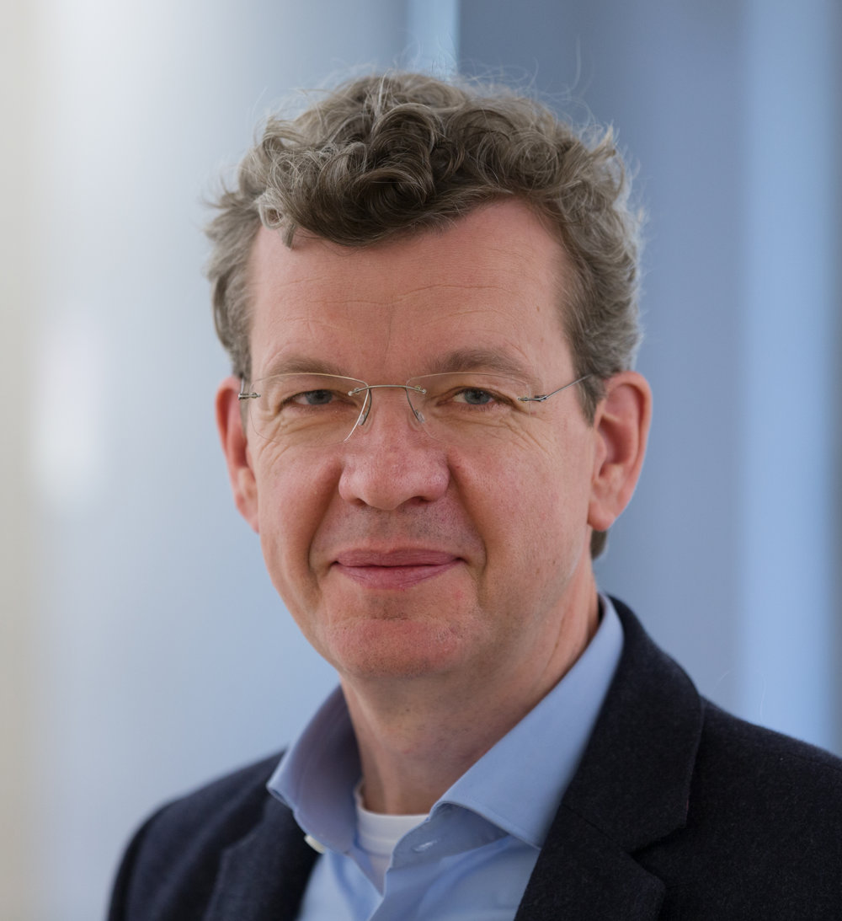
Andreas Tweitmann, CEO of RTW adds: “The fact that the prestigious SAE Institute embraces the significance of monitoring audio visually is crucial, and we naturally hope that many of the students and instructors will make use of this arrangement and eventually make it second nature to keep their eyes on their audio, as this will help them create even better end results. Today, for themselves, but tomorrow for their employers or customers.”

/ENDS
Download hi-res photo (Andreas Tweitmann)
Read recent RTW press releases here...

[Plain Text Version]
RTW Teams up with European SAE Institutes
(Cologne, Germany, 27 June 2019) Students and instructors at the SAE Institute takes audio production very seriously, and the ultimate goal is to prepare the students to become highly skilled audio professionals within music production, post, film, broadcast, etc.
Recognizing the importance of monitoring audio visually when working with sound, the European SAE institutes now teams up with German audio meter developer, designer and manufacturer RTW in order to offer its students and instructors a 40% discount on the company’s audio meter plugin solutions.
“To us, it was as an absolute no-brainer,” says Lukas Middelmann, SAE Industry Relations & Career Coach at the institute in Cologne. ”We always aim at giving our students the most realistic working conditions during their education, and a key part of a professional audio environment is reliable metering that assists your ears when making important mixing and mastering decisions.
So, when the opportunity to offer our students a special discount on the RTW software audio meters, we immediately sealed the deal.
And we encourage all of our students to take advantage of this opportunity to familiarize themselves with the concept of advanced audio metering before entering a professional production facility where it is expected that you know how to read visual information about audio – and how to react to that information.”
Andreas Tweitmann, CEO of RTW adds: “The fact that the prestigious SAE Institute embraces the significance of monitoring audio visually is crucial, and we naturally hope that many of the students and instructors will make use of this arrangement and eventually make it second nature to keep their eyes on their audio, as this will help them create even better end results. Today, for themselves, but tomorrow for their employers or customers.”
/ENDS

