

FOR IMMEDIATE RELEASE

RTW TouchMonitor with Ravenna/AES67 Now Shipping

The RTW TM Ravenna that was announced and previewed at IBC 2019 is now available worldwide.

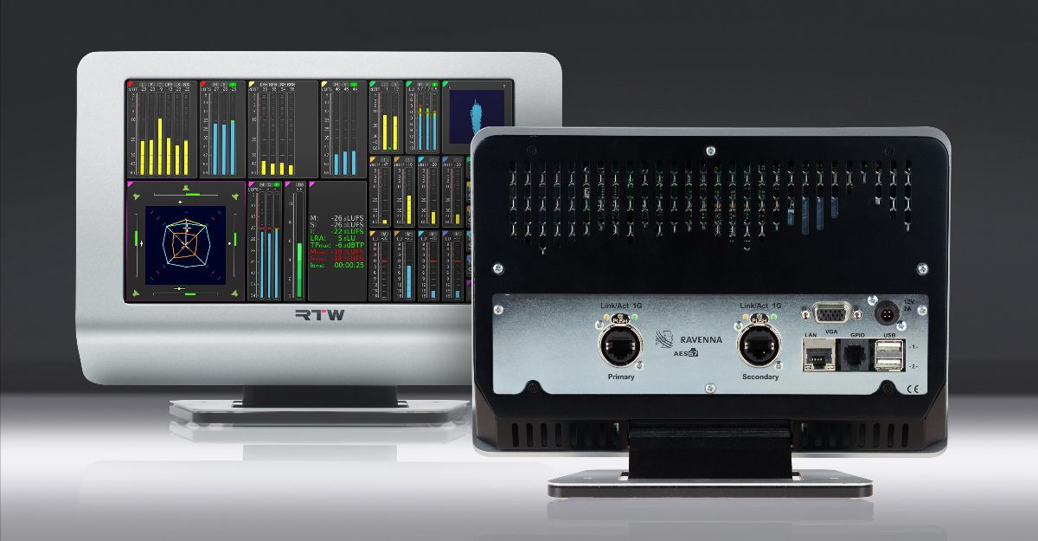

(25 February 2020, Cologne, Germany) RTW focuses on visualizing audio in order to let audio engineers make informed decisions in professional broadcast, production, post production and quality control, and as broadcasters are increasingly moving toward networked audio, the company now presents a new version of its acclaimed TouchMonitor TM7 and TM9.
These two new audio meters with I/O cards that are enabled for connecting with Ravenna or AES67-based IP Audio networks right out of the box is now available through RTW dealers worldwide.
These new meters align perfectly with RTW’s strategic efforts to embrace networked audio. Last year, Dante versions of TouchMonitor TM7 and TM9 were introduced, and with these new and even more broadcast-focused meters, two key bases within the IP Audio sphere are covered in full.


“We recognize that many broadcasters today are in a transition phase, moving towards networked audio,” says Andreas Tweitmann, CEO of RTW. “Therefore, it has been – and continues to be – a priority that we make sure any broadcaster who decides to take this significant step is able to integrate our audio metering solutions seamlessly as part of their network. I am pleased that both our Ravenna and Dante meters are now on the market.”

/ENDS
Availability
Now
Hi-res Images
Download hi-res photo (TM Ravenna)
Download hi-res photo (Andreas Tweitmann)
More Information:
RTW TM Ravenna Details
Please note! Plain text version available below.

About RTW
RTW, based in Cologne (Germany), has more than 50 years of experience designing, producing and marketing advanced recording-studio equipment, leading and innovating the marketforhighquality audio metering and monitoring tools. RTW operates a worldwide distribution and service network. For more information on RTW, visit www.rtw.com, www.facebook.com/rtwaudio or call +49 221 709130.

[PLAIN TEXT VERSION]
RTW TouchMonitor with Ravenna/AES67 Now Shipping
The RTW TM Ravenna that was announced and previewed at IBC 2019 is now available worldwide.
(25 February 2020, Cologne, Germany) RTW focuses on visualizing audio in order to let audio engineers make informed decisions in professional broadcast, production, post production and quality control, and as broadcasters are increasingly moving toward networked audio, the company now presents a new version of its acclaimed TouchMonitor TM7 and TM9.
These two new audio meters with I/O cards that are enabled for connecting with Ravenna or AES67-based IP Audio networks right out of the box is now available through RTW dealers worldwide.
These new meters align perfectly with RTW’s strategic efforts to embrace networked audio. Last year, Dante versions of TouchMonitor TM7 and TM9 were introduced, and with these new and even more broadcast-focused meters, two key bases within the IP Audio sphere are covered in full.
“We recognize that many broadcasters today are in a transition phase, moving towards networked audio,” says Andreas Tweitmann, CEO of RTW. “Therefore, it has been – and continues to be – a priority that we make sure any broadcaster who decides to take this significant step is able to integrate our audio metering solutions seamlessly as part of their network. I am pleased that both our Ravenna and Dante meters are now on the market.”
/ENDS

