

FOR IMMEDIATE RELEASE

RTW Introduces TouchMonitor with Ravenna/AES67 at IBC 2019

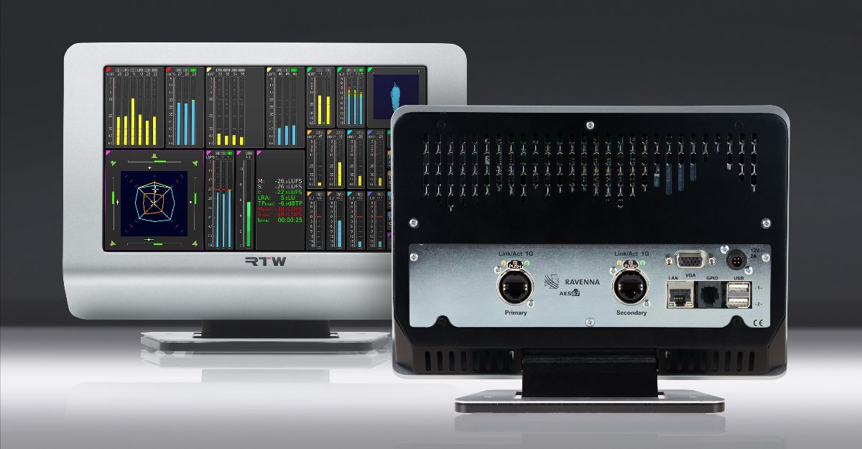

(12 September 2019, Amsterdam, Netherlands) RTW focuses on visualizing audio in order to let audio engineers make informed decisions in professional broadcast, production, post production and quality control, and as broadcasters are increasingly moving toward networked audio, the company now presents a new version of its acclaimed TouchMonitor TM7 and TM9.
These two new audio meters with I/O cards that are enabled for connecting with Ravenna or AES67-based IP Audio networks right out of the box will be on display at the RTW IBC Booth (D89, Hall 8).
These new meters align perfectly with RTW’s strategic efforts to embrace networked audio. Earlier this year, Dante versions of TouchMonitor TM7 and TM9 were introduced, and with these brand-new and even more broadcast-focused meters, two key bases within the IP Audio sphere are covered in full.


“We recognize that many broadcasters today are in a transition phase, moving towards networked audio,” says Andreas Tweitmann, CEO of RTW. “Therefore, it has been – and continues to be – a priority that we make sure any broadcaster who decides to take this significant step is able to integrate our audio metering solutions seamlessly as part of their network.”

The TM Ravenna/AES67 TouchMonitors will be available Q4 2019 worldwide.
/ENDS
Availability
Q4 2019
Hi-res Images
Download hi-res photo (TM Ravenna)
Download hi-res photo (Andreas Tweitmann)
German Version
Download German version of this press release (PDF)
Please note! Plain text version available below.

About RTW
RTW, based in Cologne (Germany), has more than 50 years of experience designing, producing and marketing advanced recording-studio equipment, leading and innovating the marketforhighquality audio metering and monitoring tools. RTW operates a worldwide distribution and service network. For more information on RTW, visit www.rtw.com, www.facebook.com/rtwaudio or call +49 221 709130.

[PLAIN TEXT VERSION]
RTW Introduces TouchMonitor with Ravenna/AES67 at IBC 2019
(12 September 2019, Amsterdam, Netherlands) RTW focuses on visualizing audio in order to let audio engineers make informed decisions in professional broadcast, production, post production and quality control, and as broadcasters are increasingly moving toward networked audio, the company now presents a new version of its acclaimed TouchMonitor TM7 and TM9.
These two new audio meters with I/O cards that are enabled for connecting with Ravenna or AES67-based IP Audio networks right out of the box will be on display at the RTW IBC Booth (D89, Hall 8).
These new meters align perfectly with RTW’s strategic efforts to embrace networked audio. Earlier this year, Dante versions of TouchMonitor TM7 and TM9 were introduced, and with these brand-new and even more broadcast-focused meters, two key bases within the IP Audio sphere are covered in full.
“We recognize that many broadcasters today are in a transition phase, moving towards networked audio,” says Andreas Tweitmann, CEO of RTW. “Therefore, it has been – and continues to be – a priority that we make sure any broadcaster who decides to take this significant step is able to integrate our audio metering solutions seamlessly as part of their network.”
The TM Ravenna/AES67 TouchMonitors will be available Q4 2019 worldwide.
/ENDS

