

RTW PRESS RELEASE
FOR IMMEDIATE RELEASE

NAB19: RTW to Team up with Avid

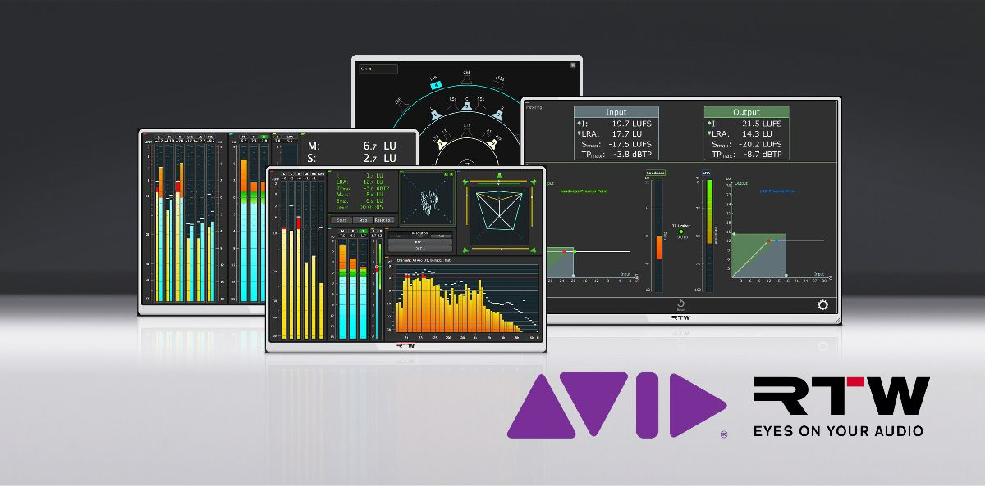

(Cologne, Germany, 5 April 2019) RTW focuses on visualizing audio in order to let audio engineers make informed decisions in professional broadcast, production, post production and quality control. In addition to the company’s wide range of hardware audio meters, it also offers its audio measuring tools as plug-in suites that are aimed at specific types of applications within broadcast and audio post production.
Now, RTW and Avid initiate a partnership to bring RTW Mastering Tools, RTW Loudness Tools and CLC Continuous Loudness Control to the Avid Marketplace in stereo as well as stereo+surround versions. And with the recent 4.1 update of the RTW plug-ins, these audio measuring and correcting tools now stand stronger together with Avid’s Pro Tools than ever before.


“We’re proud to announce this partnership with Avid, who is a key market leader within digital audio editing,” says Andreas Tweitmann, CEO of RTW. “
It is always important to us that we remain accessible to all customers, and the Avid Marketplace is strategically a great place to add as an option for our customers.”

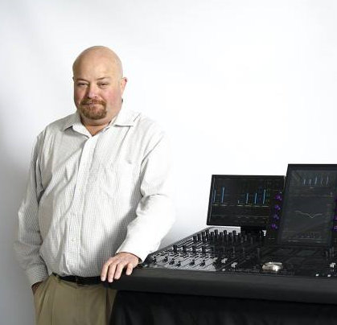
“It is a pleasure to welcome RTW as a plug-in provider, as they represent decades of experience and proven results in the field of measuring audio and presenting it visually. We are certain their tools will benefit many Pro Tools users around the world,” comments Ed Gray, Director, Partnering Programs, Avid.

Enhanced Pro Tools Support
The multi-channel features of the surround plug-ins have been improved, as the surround version now aligns with the Pro Tools channel layout from mono and up to 8 channels. Further, in the setup page, a new channel activity indicator makes it significantly easier for users to set up their multi-channel workflows.
Operating System Compatibility
The new version 4.1 of the RTW plug-ins is compatible with the latest operating systems, including Mac OS Mojave and Windows 10 in order to integrate with any system. This applies to both the original stereo+surround edition, as well as the stereo-only version.
/ENDS
Availability
Now
Pricing
Stereo+surround
RTW Loudness Tools: $239
RTW Mastering Tools: $599
CLC - Continuous Loudness Control: $999
Stereo-only
RTW Loudness Tools: $89
RTW Mastering Tools: $199
CLC - Continuous Loudness Control: $299
Links to RTW plug-ins at the Avid Marketplace:
CLC - Continuous Loudness Control
https://www.avid.com/plugins/CLC-continuous-loudness-control
https://www.avid.com/plugins/CLC-continuous-loudness-control-stereo
RTW Loudness Tools
https://www.avid.com/plugins/RTW-Loudness-tools
https://www.avid.com/plugins/RTW-Loudness-tools-stereo
RTW Mastering Tools
https://www.avid.com/plugins/RTW-mastering-tools
https://www.avid.com/plugins/rtw-mastering-tools-stereo
Please note! Plain text version available below.

About RTW
RTW, based in Cologne (Germany), has more than 50 years of experience designing, producing and marketing advanced recording-studio equipment, leading and innovating the marketforhigh quality audio metering and monitoring tools. RTW operates a worldwide distribution and service network. For more information on RTW, visit www.rtw.com, www.facebook.com/rtwaudio or call +49 221 709130.

[PLAIN TEXT VERSION]
(Cologne, Germany, 5 April 2019) RTW focuses on visualizing audio in order to let audio engineers make informed decisions in professional broadcast, production, post production and quality control. In addition to the company’s wide range of hardware audio meters, it also offers its audio measuring tools as plug-in suites that are aimed at specific types of applications within broadcast and audio post production.
Now, RTW and Avid initiate a partnership to bring RTW Mastering Tools, RTW Loudness Tools and CLC Continuous Loudness Control to the Avid Marketplace in stereo as well as stereo+surround versions. And with the recent 4.1 update of the RTW plug-ins, these audio measuring and correcting tools now stand stronger together with Avid’s Pro Tools than ever before.
“We’re proud to announce this partnership with Avid, who is a key market leader within digital audio editing,” says Andreas Tweitmann, CEO of RTW. “
It is always important to us that we remain accessible to all customers, and the Avid Marketplace is strategically a great place to add as an option for our customers.”
“It is a pleasure to welcome RTW as a plug-in provider, as they represent decades of experience and proven results in the field of measuring audio and presenting it visually. We are certain their tools will benefit many Pro Tools users around the world,” comments Ed Gray, Director, Partnering Programs, Avid.
Enhanced Pro Tools Support
The multi-channel features of the surround plug-ins have been improved, as the surround version now aligns with the Pro Tools channel layout from mono and up to 8 channels. Further, in the setup page, a new channel activity indicator makes it significantly easier for users to set up their multi-channel workflows.
Operating System Compatibility
The new version 4.1 of the RTW plug-ins is compatible with the latest operating systems, including Mac OS Mojave and Windows 10 in order to integrate with any system. This applies to both the original stereo+surround edition, as well as the stereo-only version.
/ENDS

