

RTW PRESS RELEASE
FOR IMMEDIATE RELEASE

RTW TouchMonitor with Dante Wins 2019 NAB Show Product of the Year Award
The brand-new versions of TouchMonitor TM7 and TM9 with Dante connectivity awarded at NAB 2019.

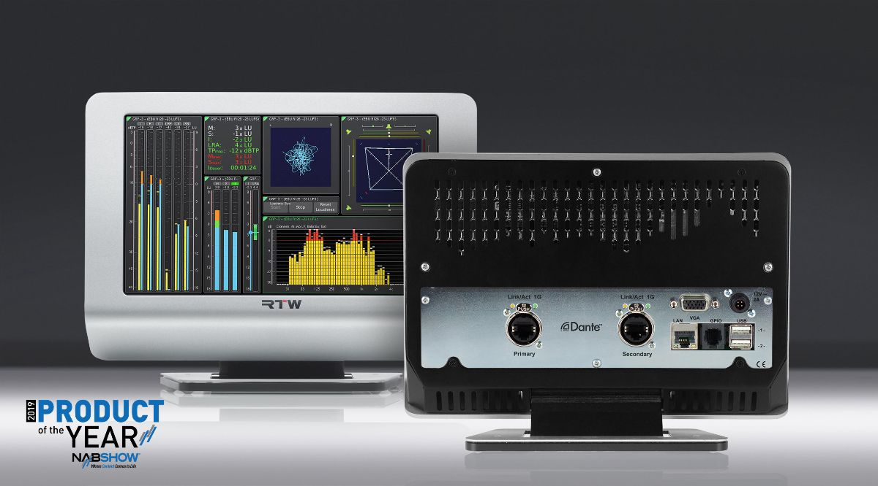

(Cologne, Germany, 25 April 2019) RTW, a company that focuses on visualizing audio in order to let audio engineers take informed decisions in professional broadcast, production, post production and quality control, announced today that its TM-Dante is a Best New Audio Production, Processing and Networking Technology winner in the 2019 NAB Show Product of the Year Awards.
These are the first official awards that recognize innovative new products at NAB Show, the program recognizes the most significant and promising new products and technologies showcased by Exhibitors at the 2019 NAB Show in Las Vegas, NV.

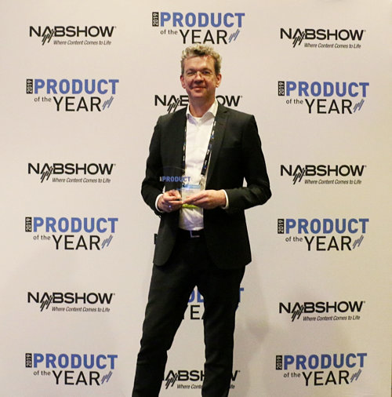
“We are honored that our audio metering solution that taps directly into the networked audio world of Dante and AES67 has won this prestigious award, handed out by the NAB organization,” says Andreas Tweitmann, CEO of RTW. “It is our mission to give all audio engineers the opportunity to keep their eyes on their audio at all times and thereby deliver the best-sounding results possible.

And since more and more broadcast and post production facilities are moving toward Dante / AES67 network infrastructure, it makes perfect sense to add this connectivity for the latest incarnation of the TM7 and TM9 units. Having NAB also recognizing the need for such a solution in modern broadcast just makes it even better.”
NAB Show Product of the Year Award Winners were selected by a panel of industry experts in 16 categories and announced at an awards ceremony and cocktail reception at the Westgate Las Vegas Resort on April 10. To be eligible for an award, nominated products and technologies needed to be on display at the 2019 NAB Show for the first time and available for delivery in calendar year 2019.
“Nominees like RTW are revolutionizing the way people experience media and entertainment,” adds NAB Executive Vice President of Conventions and Business Operations Chris Brown. “The 2019 NAB Show Product of the Year Awards highlight the best of what’s new at the premier launchpad for breakthroughs at the intersection of media, entertainment and technology.”
About TM7 and TM9 with Dante
A TouchMonitor with Dante connectivity is able to monitor up to 32 audio channels at sample rates up to 96 kHz. The selected sample rate does not affect the channel count, which means that users can always rely on keeping their eyes on up to 32 channels across the IP Audio Network at any given time.
Apart from measuring critical audio-related factors such as Loudness, True-Peak, Correlation, Frequency Distribution, etc., users now also get instant and visible feedback on the overall status of the audio network. This allows for quick troubleshooting and identification of potential problems that may cause critical downtime.
In broadcast, reliability is always paramount. Therefore, the new Dante-ready TM7 and TM9 units support redundant network connectivity to ensure that users are always able to get an overview of their audio at a glance. Quite simply, with a Dante-enabled TouchMonitor TM7 or TM9 hooked up to their Dante / AES67 network, broadcast engineers will never be forced to ‘work in the dark’.
TouchMonitor TM7 and TM9 with Dante compatibility automatically detect and adapt to Dante channel names, which in turn makes routing a breeze when setting up the audio metering system on the network.
Finally, RTW has implemented uncompressed, multi-channel digital audio technology that results in near-zero latency and synchronization performance for obtaining the most reliable and consistent results possible.
/ENDS
Learn More About TM Dante
Download Photo
Read recent RTW press releases here...
Please note! Plain text version available below.

About RTW
RTW, based in Cologne (Germany), has more than 50 years of experience designing, producing and marketing advanced recording-studio equipment, leading and innovating the marketforhigh quality audio metering and monitoring tools. RTW operates a worldwide distribution and service network. For more information on RTW, visit www.rtw.com, www.facebook.com/rtwaudio or call +49 221 709130.

[PLAIN TEXT VERSION]
RTW TouchMonitor with Dante Wins 2019 NAB Show Product of the Year Award
The brand-new versions of TouchMonitor TM7 and TM9 with Dante connectivity awarded at NAB 2019.
(Cologne, Germany, 25 April 2019) RTW, a company that focuses on visualizing audio in order to let audio engineers take informed decisions in professional broadcast, production, post production and quality control, announced today that its TM-Dante is a Best New Audio Production, Processing and Networking Technology winner in the 2019 NAB Show Product of the Year Awards.
These are the first official awards that recognize innovative new products at NAB Show, the program recognizes the most significant and promising new products and technologies showcased by Exhibitors at the 2019 NAB Show in Las Vegas, NV.
“We are honored that our audio metering solution that taps directly into the networked audio world of Dante and AES67 has won this prestigious award, handed out by the NAB organization,” says Andreas Tweitmann, CEO of RTW. “It is our mission to give all audio engineers the opportunity to keep their eyes on their audio at all times and thereby deliver the best-sounding results possible. And since more and more broadcast and post production facilities are moving toward Dante / AES67 network infrastructure, it makes perfect sense to add this connectivity for the latest incarnation of the TM7 and TM9 units. Having NAB also recognizing the need for such a solution in modern broadcast just makes it even better.”
NAB Show Product of the Year Award Winners were selected by a panel of industry experts in 16 categories and announced at an awards ceremony and cocktail reception at the Westgate Las Vegas Resort on April 10. To be eligible for an award, nominated products and technologies needed to be on display at the 2019 NAB Show for the first time and available for delivery in calendar year 2019.
“Nominees like RTW are revolutionizing the way people experience media and entertainment,” adds NAB Executive Vice President of Conventions and Business Operations Chris Brown. “The 2019 NAB Show Product of the Year Awards highlight the best of what’s new at the premier launchpad for breakthroughs at the intersection of media, entertainment and technology.”
About TM7 and TM9 with Dante
A TouchMonitor with Dante connectivity is able to monitor up to 32 audio channels at sample rates up to 96 kHz. The selected sample rate does not affect the channel count, which means that users can always rely on keeping their eyes on up to 32 channels across the IP Audio Network at any given time.
Apart from measuring critical audio-related factors such as Loudness, True-Peak, Correlation, Frequency Distribution, etc., users now also get instant and visible feedback on the overall status of the audio network. This allows for quick troubleshooting and identification of potential problems that may cause critical downtime.
In broadcast, reliability is always paramount. Therefore, the new Dante-ready TM7 and TM9 units support redundant network connectivity to ensure that users are always able to get an overview of their audio at a glance. Quite simply, with a Dante-enabled TouchMonitor TM7 or TM9 hooked up to their Dante / AES67 network, broadcast engineers will never be forced to ‘work in the dark’.
TouchMonitor TM7 and TM9 with Dante compatibility automatically detect and adapt to Dante channel names, which in turn makes routing a breeze when setting up the audio metering system on the network.
Finally, RTW has implemented uncompressed, multi-channel digital audio technology that results in near-zero latency and synchronization performance for obtaining the most reliable and consistent results possible.
/ENDS

