

FOR IMMEDIATE RELEASE

RTW Releases Global Loudness Delivery Guide for Content Providers

While aligning the perceived loudness of content in broadcast and digital delivery platforms such as Spotify, YouTube, Apple Music and more is a good initiative, one of the consequences is a wealth of new delivery standards. RTW sets out to provide an overview.

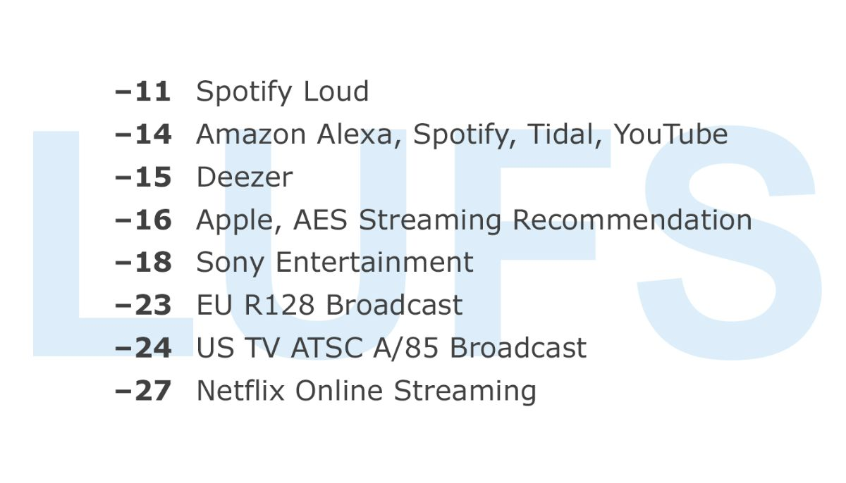

(20 May 2020, Cologne, Germany) Loudness standards is not a new thing in the broadcast sphere, as they have been around for about a decade by now. In the meantime, however, many new digital streaming platforms has seen the light of day. And in recent years, the companies behind these new platforms have also started to recognize the need for recommending specific loudness deliver specifications to its content providers.
Therefore, companies such as Spotify, Netflix, Apple, Sony, Amazon, Tidal and Google (YouTube) now have their own loudness delivery guidelines. Some of them are similar in terms of Integrated Loudness (LUFS), but may vary slightly with regard to True Peak (dBTP), and then again some are simply the same.


“With so many different streaming services around these days, we saw a need for gathering all of the available information in one place so that content providers can get an easy overview,” says Mike Kahsnitz, RTW Senior Director of Product Management.
“For instance, if you make music and would like to submit your content to Spotify, Apple Music, Amazon Music, Tidal and Deezer, you should not just bounce one file for all of them. There simply is no one-size-fits-all solution.

In broadcast, there are also many standards. Depending on region, individual country and content type, we have found 35 different specifications that are all listed on our website. Including the streaming platforms, we have nearly 50 instances, and it is our hope that content providers will see this as a helpful resource and may bookmark it as a future reference when delivering digital content. We are of course dedicated to maintain the list and update it in case specifications may change at some point, or when new ones arise in the future.”
The loudness delivery specifications on the RTW page all include Loudness and True Peak targets, and depending on content type and destination, parameters such as Short Term Loudness, Momentary Loudness and Max Loudness Range may also be included.

/ENDS
Link:
RTW's Global Loudness Delivery Guide
Hi-res Images
Download hi-res photo (Mike Kahsnitz)
Please note! Plain text version available below.

About RTW
RTW, based in Cologne (Germany), has more than 50 years of experience designing, producing and marketing advanced recording-studio equipment, leading and innovating the market for high quality audio metering and monitoring tools. RTW operates a worldwide distribution and service network. For more information on RTW, visit www.rtw.com, www.facebook.com/rtwaudio or call +49 221 709130.

[PLAIN TEXT VERSION]
RTW Releases Global Loudness Delivery Guide for Content Providers
While aligning the perceived loudness of content in broadcast and digital delivery platforms such as Spotify, YouTube, Apple Music and more is a good initiative, one of the consequences is a wealth of new delivery standards. RTW sets out to provide an overview.
(20 May 2020, Cologne, Germany) Loudness standards is not a new thing in the broadcast sphere, as they have been around for about a decade by now. In the meantime, however, many new digital streaming platforms has seen the light of day. And in recent years, the companies behind these new platforms have also started to recognize the need for recommending specific loudness deliver specifications to its content providers.
Therefore, companies such as Spotify, Netflix, Apple, Sony, Amazon, Tidal and Google (YouTube) now have their own loudness delivery guidelines. Some of them are similar in terms of Integrated Loudness (LUFS), but may vary slightly with regard to True Peak (dBTP), and then again some are simply the same.
“With so many different streaming services around these days, we saw a need for gathering all of the available information in one place so that content providers can get an easy overview,” says Mike Kahsnitz, RTW Senior Director of Product Management.
“For instance, if you make music and would like to submit your content to Spotify, Apple Music, Amazon Music, Tidal and Deezer, you should not just bounce one file for all of them. There simply is no one-size-fits-all solution.
In broadcast, there are also many standards. Depending on region, individual country and content type, we have found 35 different specifications that are all listed on our website. Including the streaming platforms, we have nearly 50 instances, and it is our hope that content providers will see this as a helpful resource and may bookmark it as a future reference when delivering digital content. We are of course dedicated to maintain the list and update it in case specifications may change at some point, or when new ones arise in the future.”
The loudness delivery specifications on the RTW page all include Loudness and True Peak targets, and depending on content type and destination, parameters such as Short Term Loudness, Momentary Loudness and Max Loudness Range may also be included.
/ENDS

