

FOR IMMEDIATE RELEASE

RTW to Demonstrate New Olympics-Ready Immersive License for Its TouchMonitor TM7 and TM9 at IBC 2019

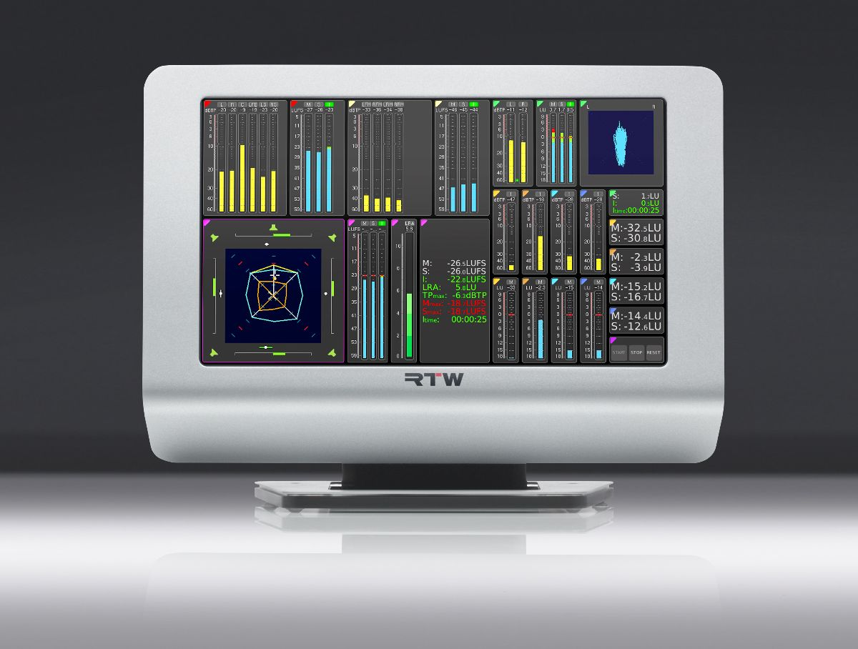

(10 September 2019, Cologne, Germany) RTW focuses on visualizing audio in order to let audio engineers make informed decisions in professional broadcast, production, post production and quality control. Immersive audio formats are becoming more and more important in professional broadcast, and for example the 2020 Olympics in Japan will be prepared for broadcasters to transmit immersive audio.
To meet this demand, premium and reliable audio metering is more critical than ever. Therefore, RTW has developed an immersive audio license, ISA Immersive Sound Analyzer, for its TouchMonitor TM7 and TM9 audio meters that will be demonstrated at Booth D89 in Hall 8 as part of a technical setup that replicates the audio side of the 2020 Olympics broadcast.
The new license enables audio metering of several variants of the Dolby Atmos® immersive audio format. Besides offering all relevant metering instruments, users will also be able to monitor various loudness measures, including Integrated, Momentary and Short-Term loudness across an entire Dolby Atmos® stream – also channels that carry audio objects.


“Immersive audio formats have arrived to stay and the transition has merely just begun,” says Andreas Tweitmann, CEO of RTW. “Therefore, we’re very excited to announce the new ISA license for our TM9 and TM7 units that allows existing users to simply add this crucial functionality. And of course, it represents yet another reason for new users to join the TM-platform, stepping into the future of immersive audio in broadcast.”

With the ISA license, audio engineers in broadcast and post production will be able to monitor 5.1.2, 5.1.4, 7.1.2 or 7.1.4. In reality, two surround sound analyzers are combined, which allows for monitoring both the main bed (5.1 or 7.1), as well as the upper bed (2.0 or 4.0) in a single easy-to-read view.
The ISA - Immersive Sound Analyzer license will be available immediately
after IBC 2019 and is available for all TM7 and TM9 models running software version 8-10 or higher. The following additional software licenses are required to run ISA: Multichannel Mode, Loudness and SPL Display and Surround Sound Analyzer.
/ENDS
Availability
18 September 2019
Pricing
590 EUR (ex VAT)
678,50 USD
Hi-res Images
Download hi-res photo (immersive License on TM9)
Download hi-res photo (Andreas Tweitmann)
German Version
Download German version of this press release (PDF)
Please note! Plain text version available below.

About RTW
RTW, based in Cologne (Germany), has more than 50 years of experience designing, producing and marketing advanced recording-studio equipment, leading and innovating the marketforhighquality audio metering and monitoring tools. RTW operates a worldwide distribution and service network. For more information on RTW, visit www.rtw.com, www.facebook.com/rtwaudio or call +49 221 709130.

[PLAIN TEXT VERSION]
RTW to Demonstrate New Olympics-Ready Immersive License for Its TouchMonitor TM7 and TM9 at IBC 2019
(10 September 2019, Cologne, Germany) RTW focuses on visualizing audio in order to let audio engineers make informed decisions in professional broadcast, production, post production and quality control. Immersive audio formats are becoming more and more important in professional broadcast, and for example the 2020 Olympics in Japan will be prepared for broadcasters to transmit immersive audio.
To meet this demand, premium and reliable audio metering is more critical than ever. Therefore, RTW has developed an immersive audio license, ISA Immersive Sound Analyzer, for its TouchMonitor TM7 and TM9 audio meters that will be demonstrated at Booth D89 in Hall 8 as part of a technical setup that replicates the audio side of the 2020 Olympics broadcast.
The new license enables audio metering of several variants of the Dolby Atmos® immersive audio format. Besides offering all relevant metering instruments, users will also be able to monitor various loudness measures, including Integrated, Momentary and Short-Term loudness across an entire Dolby Atmos® stream – also channels that carry audio objects.
“Immersive audio formats have arrived to stay and the transition has merely just begun,” says Andreas Tweitmann, CEO of RTW. “Therefore, we’re very excited to announce the new ISA license for our TM9 and TM7 units that allows existing users to simply add this crucial functionality. And of course, it represents yet another reason for new users to join the TM-platform, stepping into the future of immersive audio in broadcast.”
With the ISA license, audio engineers in broadcast and post production will be able to monitor 5.1.2, 5.1.4, 7.1.2 or 7.1.4. In reality, two surround sound analyzers are combined, which allows for monitoring both the main bed (5.1 or 7.1), as well as the upper bed (2.0 or 4.0) in a single easy-to-read view.
The ISA - Immersive Sound Analyzer license will be available immediately
after IBC 2019 and is available for all TM7 and TM9 models running software version 8-10 or higher. The following additional software licenses are required to run ISA: Multichannel Mode, Loudness and SPL Display and Surround Sound Analyzer.
/ENDS

