

FOR IMMEDIATE RELEASE

RTW Audio Showcases TouchControl 5 at IBC 2022

RTW Audio introduces a new AoIP-focused monitor controller with onboard metering features that is ready to integrate seamlessly with Audinate® Dante® audio-over-IP networks.

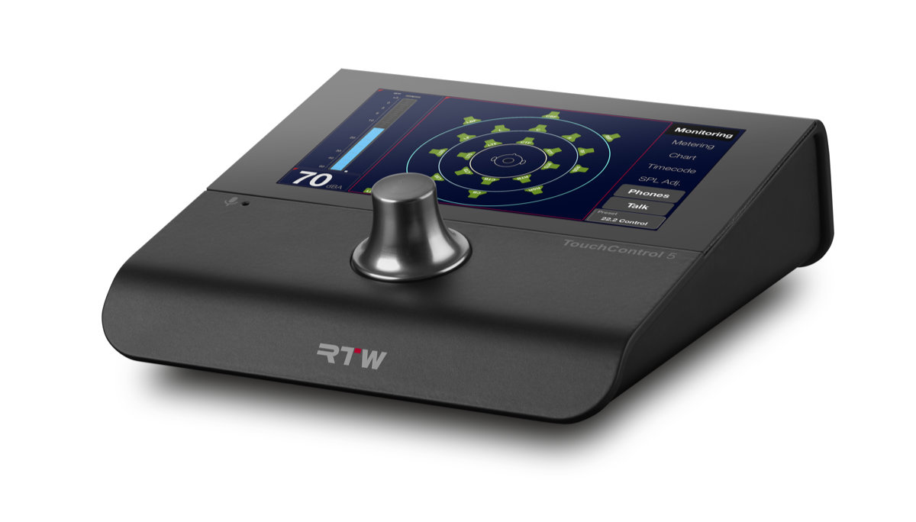

(25 August 2022, Cologne, Germany) RTW recently expanded its focus on visualizing audio in broadcast, production, post production and quality control to also comprise monitor control. In fact, RTW is no newcomer to monitor control, as it has a long history of providing advanced monitor controller devices that are still in use at many broadcast stations. However, the focus has been on metering in recent years, but the company now makes monitor control a focal area as well with the introduction of TouchControl 5.
TouchControl 5 is a monitor controller and audio meter with an intuitive user interface and a small footprint that preserves valuable desktop real estate, featuring a 5” touchscreen, as well as a rotary knob that also functions as a push button for easy access to dim or mute functions. The screen layout can effortlessly be customized by the user via a browser-based application, and TouchControl 5 is able to control up to 32 AoIP audio channels, making it compatible with audio formats from mono to immersive within a Dante® audio network.
“We are very happy to once again take on monitor control with an updated and relevant product designed specifically to manage audio channels on an IP Audio network,” says Andreas Tweitmann, CEO of RTW.


“No doubt, there is a huge demand for monitor control solutions that are able to naturally and easily integrate with Dante® and AES67. On top of that, with the touchscreen it was an obvious bonus to also offer a selection of our world-class metering solutions as options that you can add either from the start, or as your needs grow along the way.”

TouchControl 5 will be on display and demo for the first time in Europe at IBC 2022 Booth 8.D75 September 9-12 in Amsterdam.

/ENDS
Hi-res Images
Download hi-res photo (TouchControl 5 - 300dpi grey background)
Download hi-res photo (TouchControl 5 - 300dpi white background)
Download hi-res photo (TouchControl 5 - 300dpi no background)
Download hi-res photo (Andreas Tweitmann)
Additional Info:
TouchControl 5 Product Page
TouchControl 5 Overview Video
Pricing
TouchControl 5 Basic: €999 / $1,148.85 USD
TouchControl 5 Monitor Controller (Monitoring & Multichannel Licenses): €2,319 / $2,666.85
Monitoring License: €660 / $759 USD
Multichannel License: €660 / $759 USD
Premium Metering License: €440 / $506 USD
Ethernet Power Injector: From €69 / $79.35 USD
Availability
Shipping Q2 2023
Review Unit Requests
kim@pr-momentum.com
Please note! Plain text version available below.

About RTW
RTW, based in Cologne (Germany), has more than 50 years of experience designing, producing and marketing advanced recording-studio equipment, leading and innovating the market for high quality audio metering and monitoring tools. RTW operates a worldwide distribution and service network. For more information on RTW, visit www.rtw.com, www.facebook.com/rtwaudio or call +49 221 709130.

[PLAIN TEXT VERSION]
RTW Audio Showcases TouchControl 5 at IBC 2022
RTW Audio introduces a new AoIP-focused monitor controller with onboard metering features that is ready to integrate seamlessly with Audinate® Dante® audio-over-IP networks.
(25 August 2022, Cologne, Germany) RTW recently expanded its focus on visualizing audio in broadcast, production, post production and quality control to also comprise monitor control. In fact, RTW is no newcomer to monitor control, as it has a long history of providing advanced monitor controller devices that are still in use at many broadcast stations. However, the focus has been on metering in recent years, but the company now makes monitor control a focal area as well with the introduction of TouchControl 5.
TouchControl 5 is a monitor controller and audio meter with an intuitive user interface and a small footprint that preserves valuable desktop real estate, featuring a 5” touchscreen, as well as a rotary knob that also functions as a push button for easy access to dim or mute functions. The screen layout can effortlessly be customized by the user via a browser-based application, and TouchControl 5 is able to control up to 32 AoIP audio channels, making it compatible with audio formats from mono to immersive within a Dante® audio network.
“We are very happy to once again take on monitor control with an updated and relevant product designed specifically to manage audio channels on an IP Audio network,” says Andreas Tweitmann, CEO of RTW. “No doubt, there is a huge demand for monitor control solutions that are able to naturally and easily integrate with Dante® and AES67. On top of that, with the touchscreen it was an obvious bonus to also offer a selection of our world-class metering solutions as options that you can add either from the start, or as your needs grow along the way.”
TouchControl 5 will be on display and demo for the first time in Europe at IBC 2022 Booth 8.D75 September 9-12 in Amsterdam.
/ENDS

