

FOR IMMEDIATE RELEASE

RTW to Showcase New Audio Meter and License at IBC 2019

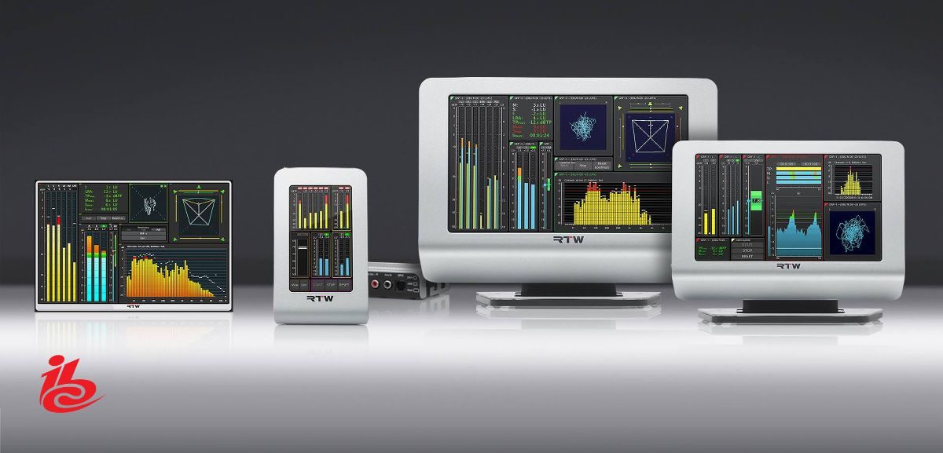

(21 August 2019, Cologne, Germany) RTW focuses on visualizing audio in order to let audio engineers make informed decisions in professional broadcast, production, post production and quality control. One of the highlights in the broadcast engineering tradeshow calendar is the annual IBC show in Amsterdam, and RTW will be present at Booth D89 in Hall 8, bringing new products for visitors to see and experience first-hand.
On the hardware side, a brand-new audio monitor in the company’s TM-range will be shown. It is a further expansion of the TM-family that is tailored to the needs of the modern broadcaster. RTW will also reveal a new license for the TM-meters, making them ‘2020-Olympics-ready’ with regard to the latest multichannel audio and transmission formats.


“It is always important for us to be present at the IBC shows,” says Andreas Tweitmann, CEO of RTW. “And especially when we have such significant news to share on both the hardware and software side of things.
We look forward to welcoming all IBC-attendees to our booth in Hall 8 where we will have a comprehensive demo setup in order to showcase the new products in a context-relevant setup.”
/ENDS

Hi-res Images
Download Image
Download hi-res photo (Andreas Tweitmann)
Please note! Plain text version available below.

About RTW
RTW, based in Cologne (Germany), has more than 50 years of experience designing, producing and marketing advanced recording-studio equipment, leading and innovating the marketforhighquality audio metering and monitoring tools. RTW operates a worldwide distribution and service network. For more information on RTW, visit www.rtw.com, www.facebook.com/rtwaudio or call +49 221 709130.

[PLAIN TEXT VERSION]
RTW to Showcase New Audio Meter and License at IBC 2019
(21 August 2019, Cologne, Germany) RTW focuses on visualizing audio in order to let audio engineers make informed decisions in professional broadcast, production, post production and quality control. One of the highlights in the broadcast engineering tradeshow calendar is the annual IBC show in Amsterdam, and RTW will be present at Booth D89 in Hall 8, bringing new products for visitors to see and experience first-hand.
On the hardware side, a brand-new audio monitor in the company’s TM-range will be shown. It is a further expansion of the TM-family that is tailored to the needs of the modern broadcaster. RTW will also reveal a new license for the TM-meters, making them ‘2020-Olympics-ready’ with regard to the latest multichannel audio and transmission formats.
“It is always important for us to be present at the IBC shows,” says Andreas Tweitmann, CEO of RTW. “And especially when we have such significant news to share on both the hardware and software side of things.
We look forward to welcoming all IBC-attendees to our booth in Hall 8 where we will have a comprehensive demo setup in order to showcase the new products in a context-relevant setup.”
/ENDS

