FOR IMMEDIATE RELEASE

RTW Appoints Group One as Service Partner in the US

(13 October 2022, Cologne, Germany) RTW, the leading metering company with focus on visualizing audio to let audio engineers take informed decisions in professional broadcast, production, post production and quality control, now expands its service capacity on the East Coast in the US by appointing Group One as its dedicated service partner.
RTW already had a US-domestic service partner with Advanced Musical Electronics Inc. in Los Angeles, and this partnership remains in full, meaning that RTW now offers local authorized service for its products to customers on both coasts, as Group One is based out of Farmingdale, New York.


“Having great and dedicated service partners is key in our industry,” says Andreas Tweitmann, CEO of RTW.
“Our metering and monitor control solutions are extremely durable and reliable, but even products of the highest quality that run 24/7 every day of the week require service sometimes.

And history shows that for instance our TouchMonitor meters remain in use at broadcast stations, post production facilities, live sound rigs and recording studios not only for years and years, but for decades and decades. Therefore, I am happy to welcome Group One and ramp up our service offerings on the ground in the US.”

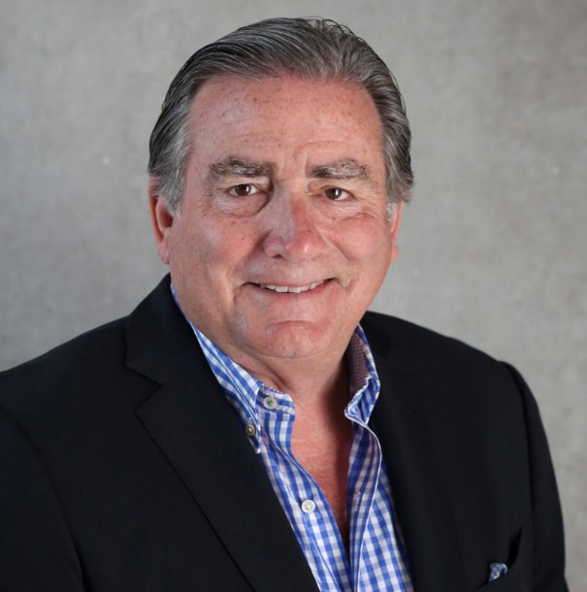
Jack Kelly, CEO of Group One adds: “For more than 30 years, we have been taking great pride in providing dedicated service of the best pro audio brands for customers in Broadcast, House of Worship, Theatre, Install, Recording and Live Sound, and we’re very excited to add RTW to that list.

Across the various areas of applications and customers that we serve, there is a unanimous recognition of the importance of having premium metering in the production setups – that part of creating great audio experiences is also rooted in having access to visualized audio. Therefore, we’re looking forward to now also be servicing RTW meters moving forward.”

/ENDS
Hi-res Image
Download hi-res photo (Andreas Tweitmann)
Download hi-res photo (Jack Kelly)
Please note! Plain text version available below.

About RTW
RTW, based in Cologne (Germany), has more than 50 years of experience designing, producing and marketing advanced recording-studio equipment, leading and innovating the market for high quality audio metering and monitoring tools. RTW operates a worldwide distribution and service network. For more information on RTW, visit www.rtw.com, www.facebook.com/rtwaudio or call +49 221 709130.
About Group One Ltd.
Group One Ltd. is a US importer and distributor for a number of professional audio and lighting manufacturers. The company’s audio division currently distributes Calrec broadcast solutions, DiGiCo digital mixing consoles, KLANG:technologies 3D immersive in-ear monitor mixing systems, Solid State Logic recording solutions, MC2 high quality innovative amplifiers, XTA digital signal processing equipment and integrated amplification, and Austrian Audio headphones and microphones. The lighting division currently distributes Avolites lighting control consoles, and elektraLite LED fixtures.

[PLAIN TEXT VERSION]
(13 October 2022, Cologne, Germany) RTW, the leading metering company with focus on visualizing audio to let audio engineers take informed decisions in professional broadcast, production, post production and quality control, now expands its service capacity on the East Coast in the US by appointing Group One as its dedicated service partner.
RTW already had a US-domestic service partner with Advanced Musical Electronics Inc. in Los Angeles, and this partnership remains in full, meaning that RTW now offers local authorized service for its products to customers on both coasts, as Group One is based out of Farmingdale, New York.
“Having great and dedicated service partners is key in our industry,” says Andreas Tweitmann, CEO of RTW. “Our metering and monitor control solutions are extremely durable and reliable, but even products of the highest quality that run 24/7 every day of the week require service sometimes. And history shows that for instance our TouchMonitor meters remain in use at broadcast stations, post production facilities, live sound rigs and recording studios not only for years and years, but for decades and decades. Therefore, I am happy to welcome Group One and ramp up our service offerings on the ground in the US.”
Jack Kelly, CEO of Group One adds: “For more than 30 years, we have been taking great pride in providing dedicated service of the best pro audio brands for customers in Broadcast, House of Worship, Theatre, Install, Recording and Live Sound, and we’re very excited to add RTW to that list. Across the various areas of applications and customers that we serve, there is a unanimous recognition of the importance of having premium metering in the production setups – that part of creating great audio experiences is also rooted in having access to visualized audio. Therefore, we’re looking forward to now also be servicing RTW meters moving forward.”
/ENDS

