FOR IMMEDIATE RELEASE

Calrec Integrates RTW Metering in New Argo Consoles

Calrec, a leading designer and supplier of broadcast audio mixing consoles and equipment, launched its new Argo series of consoles at IBC 2022. Both the larger Argo Q and the compact Argo S versions offer the option to integrate RTW metering.

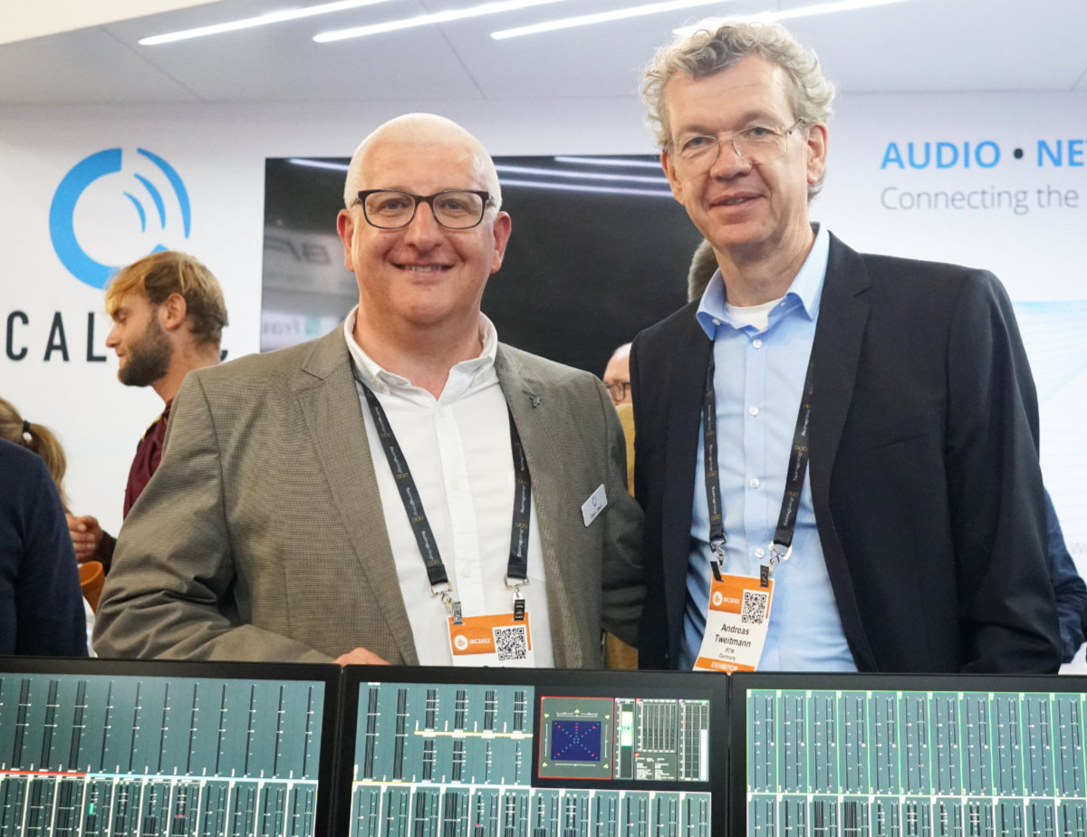

(3 October 2022, Cologne, Germany) Calrec’s longstanding partnership with RTW was first established with the integration of the RTW meter in Calrec’s Artemis audio console and has continued with the Calrec’s next-generation audio control surface, Argo. RTW provide specialist independent metering, which is both reliable and flexible, allowing users to meet changing broadcast requirements.
“Calrec users trust the RTW brand and experience. Combined with our strong relationship with RTW, it made it an easy decision when looking for metering solutions for the new Argo series,” says David Letson, VP of Sales at Calrec.
“Argo allows users to display the RTW meter directly onto our Argo screens, either on a large full screen or in a quarter of the screen with Calrec metering in the other three-quarters. We’re very excited to provide users with an even better experience which maximises on available space.”
Designed to adapt to changing production needs, Calrec’s Argo is a new approach to audio mixing, with a flexible control philosophy that breaks the traditional geographic tie lines between processing and control.
Andreas Tweitmann, CEO of RTW, adds: “When a longstanding business partner reaches out to extend a collaboration, it is the ultimate show of trust in your solution. Therefore, we were equally happy and honored when Calrec approached us to implement our meter in their new Argo series of broadcast consoles.
We immediately agreed to collaborate on the Argo series, and since we know that Calrec’s Artemis consoles are serving so many broadcasters every day of the week, we have no doubt that they will see great success with the Argo series too. I am sure that broadcasters who choose Argo, will enjoy the new paradigms of AoIP and immersive sound productions, which our meters will of course support.”
The built-in RTW meter option in both the large Argo Q and the compact Argo S is based on RTW’s TouchMonitor TM7 and includes meter licenses that cover loudness and multichannel applications. To add other metering instruments or support for immersive audio formats, additional licenses are available at shop.rtw.com or through RTW’s global network of dealers.

/ENDS
Hi-res Image
Download hi-res photo
Please note! Plain text version available below.

About RTW
RTW, based in Cologne (Germany), has more than 50 years of experience designing, producing and marketing advanced recording-studio equipment, leading and innovating the market for high quality audio metering and monitoring tools. RTW operates a worldwide distribution and service network. For more information on RTW, visit www.rtw.com, www.facebook.com/rtwaudio or call +49 221 709130.
About Calrec Audio Ltd.
For more than 50 years the world's most successful broadcasters have relied on Calrec. They still do. As our industry adapts to new viewing habits and evolving commercial environments, Calrec is helping broadcasters to stay ahead as they switch to IP infrastructures; to achieve efficiency with remote broadcasting; to save money with virtual production. Calrec’s flexible Type R can adapt to a variety of requirements including virtual, and Calrec has expanded its range of consoles, from the cost-effective Brio consoles to the IP-enabled ImPulse core. For flexible working, integrated networks and reliable audio, Calrec has it covered. More information at calrec.com.

[PLAIN TEXT VERSION]
Calrec Integrates RTW Metering in New Argo Consoles
Calrec, a leading designer and supplier of broadcast audio mixing consoles and equipment, launched its new Argo series of consoles at IBC 2022. Both the larger Argo Q and the compact Argo S versions offer the option to integrate RTW metering.
(3 October 2022, Cologne, Germany) Calrec’s longstanding partnership with RTW was first established with the integration of the RTW meter in Calrec’s Artemis audio console and has continued with the Calrec’s next-generation audio control surface, Argo. RTW provide specialist independent metering, which is both reliable and flexible, allowing users to meet changing broadcast requirements.
“Calrec users trust the RTW brand and experience. Combined with our strong relationship with RTW, it made it an easy decision when looking for metering solutions for the new Argo series,” says David Letson, VP of Sales at Calrec.
“Argo allows users to display the RTW meter directly onto our Argo screens, either on a large full screen or in a quarter of the screen with Calrec metering in the other three-quarters. We’re very excited to provide users with an even better experience which maximises on available space.”
Designed to adapt to changing production needs, Calrec’s Argo is a new approach to audio mixing, with a flexible control philosophy that breaks the traditional geographic tie lines between processing and control.
Andreas Tweitmann, CEO of RTW, adds: “When a longstanding business partner reaches out to extend a collaboration, it is the ultimate show of trust in your solution. Therefore, we were equally happy and honored when Calrec approached us to implement our meter in their new Argo series of broadcast consoles.
“We immediately agreed to collaborate on the Argo series, and since we know that Calrec’s Artemis consoles are serving so many broadcasters every day of the week, we have no doubt that they will see great success with the Argo series too. I am sure that broadcasters who choose Argo, will enjoy the new paradigms of AoIP and immersive sound productions, which our meters will of course support.”
The built-in RTW meter option in both the large Argo Q and the compact Argo S is based on RTW’s TouchMonitor TM7 and includes meter licenses that cover loudness and multichannel applications. To add other metering instruments or support for immersive audio formats, additional licenses are available at shop.rtw.com or through RTW’s global network of dealers.
/ENDS

